SECOND ANNUAL INDIAN SPRINGS

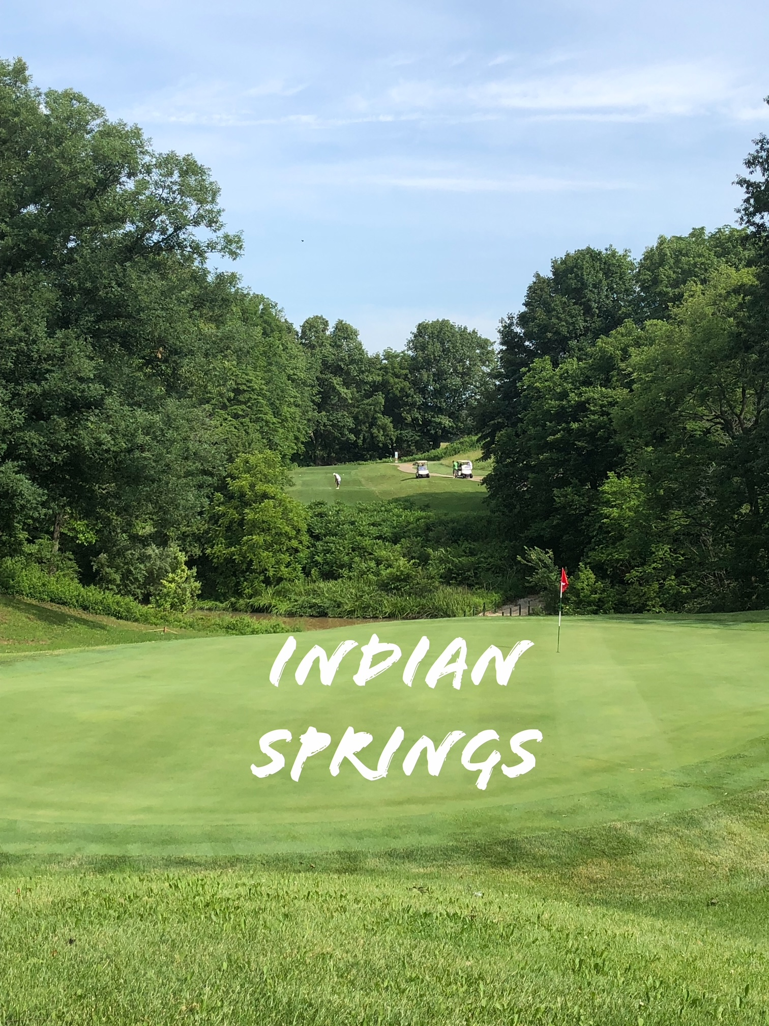

FOUR LADY SCRAMBLE

Indian Springs Golf Course - Fillmore, Illinois 62032

FRIDAY, JULY 14, 2023

**Full Field**

**Send paid entry to be on wait list.**

8:30 AM Registration Coffee & Donuts

9:30 AM Shot Gun

Limited to the first 28 fully paid teams

Deadline to enter is June 30, 2023; No refunds after July 4, 2023

* $75.00 per player ($300.00/team)
* Number of flights and places based on number of entries (ties will be split)
* Mulligans - $10.00/team (1 mulligan per player) – Pay at Registration
* Flighted Skins - $20.00/team - Pay at Registration
* Closest to the Pin on #3, #7, #11, #14, and #18
* Longest Drive (in the fairway) - 69 and under on #10 70+ on #4
* Lunch & prizes after play

Make checks payable to Nancy Marti; write Indian Springs on the memo line

Send entry form and fee to: Nancy Marti 2133 Tuscany Ridge Court, Maryville, IL 62062

Questions: [annishopkins@charter.net](mailto:annishopkins@charter.net) or [nancydmarti@charter.net](mailto:nancydmarti@charter.net)

**- - - - - - - - - - - - - - -**

PLAYER 1__________________________________

ADDRESS_______________________________ ___

CITY, STATE, ZIP

__________________________________________

PHONE____________________________________

EMAIL____________________________________

PLAYER 2__________________________________

ADDRESS_______________________________ ___

CITY, STATE, ZIP

__________________________________________

PHONE____________________________________

EMAIL____________________________________

PLAYER 3__________________________________

ADDRESS_______________________________ ___

CITY, STATE, ZIP

__________________________________________

PHONE____________________________________

EMAIL____________________________________

PLAYER 4__________________________________

ADDRESS_______________________________ ___

CITY, STATE, ZIP

__________________________________________

PHONE____________________________________

EMAIL____________________________________