FIRST ANNUAL INDIAN SPRINGS

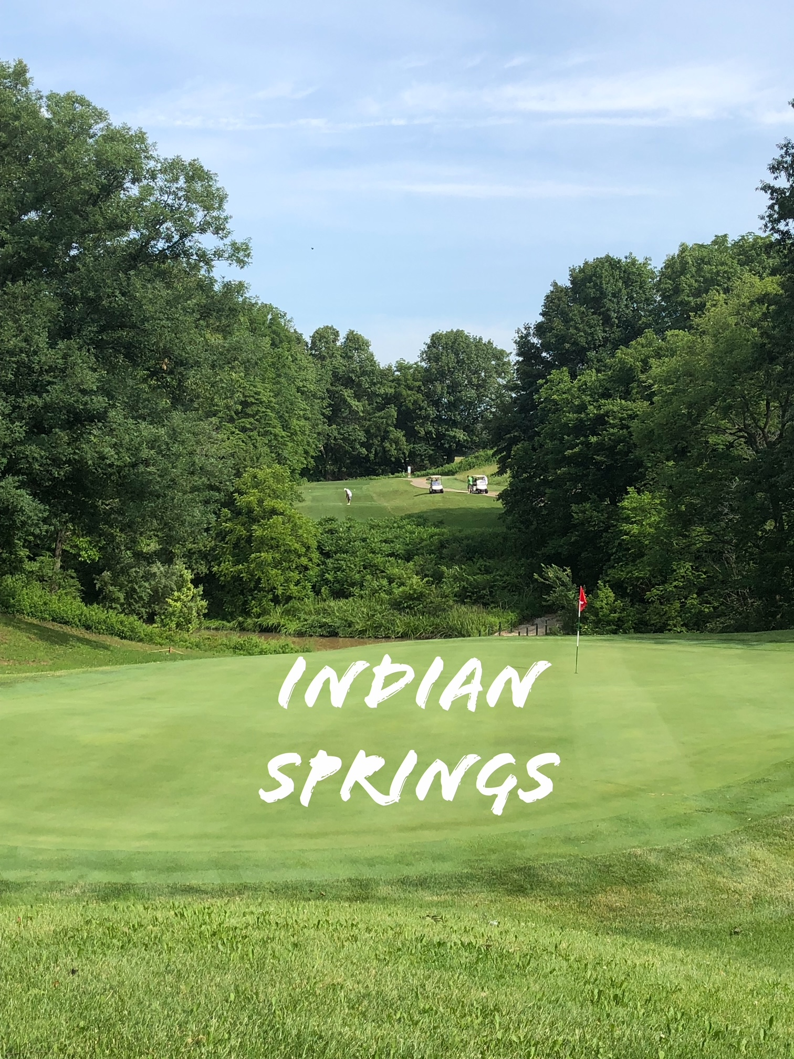

FOUR LADY SCRAMBLE

Indian Springs Golf Course - Fillmore, Illinois 62032

FRIDAY, JULY 15, 2022

8:30 AM Registration Coffee & Donuts

9:30 AM Shot Gun

Limited to the first 25 fully paid teams

* $65.00 per player ($260.00/team)
* Number of flights based on number of entries -Pay 4 Places (ties split)
* Mulligans - $5.00/team (1 per player) – Pay at Registration
* Flighted Skins - $20.00/team - Pay at Registration
* Closest to the Pin on #3, #7, #11, #14, and #18
* Longest Drive (in the fairway) - 69 and under on #10 70+ on #4
* Lunch & prizes after play

Make checks payable to Indian Springs Golf Course

Send entry form and fee to: Nancy Marti 2133 Tuscany Ridge Court, Maryville, IL 62062

**- - - - - - - - - - - - - - -**

PLAYER 1__________________________________

ADDRESS_______________________________ ___

CITY, STATE, ZIP

__________________________________________

PHONE____________________________________

EMAIL____________________________________

PLAYER 2__________________________________

ADDRESS_______________________________ ___

CITY, STATE, ZIP

__________________________________________

PHONE____________________________________

EMAIL____________________________________

PLAYER 3__________________________________

ADDRESS_______________________________ ___

CITY, STATE, ZIP

__________________________________________

PHONE____________________________________

EMAIL____________________________________

PLAYER 4__________________________________

ADDRESS_______________________________ ___

CITY, STATE, ZIP

__________________________________________

PHONE____________________________________

EMAIL____________________________________